**2. Literature Review**

Most portfolio creation processes, including idea generation, asset allocation, weight optimization, position size, and strategy testing, can be aided by machine learning. It can be categorized as below:

1. **Trading strategies** are a systematic way of buying and selling assets in the market which can be further classified into three different themes:
   1. **Price** plays a central role in input data and predicted outcomes of trading strategies. Price techniques include technical, systematic global macro, and statistical arbitrage.
   2. **Events** strategies aid in the prediction of changes such as trends, and soft and hard events.
   3. **The value** comprises risk parity and factor investing, which determine intermediary values that are not directly tied to asset prices.

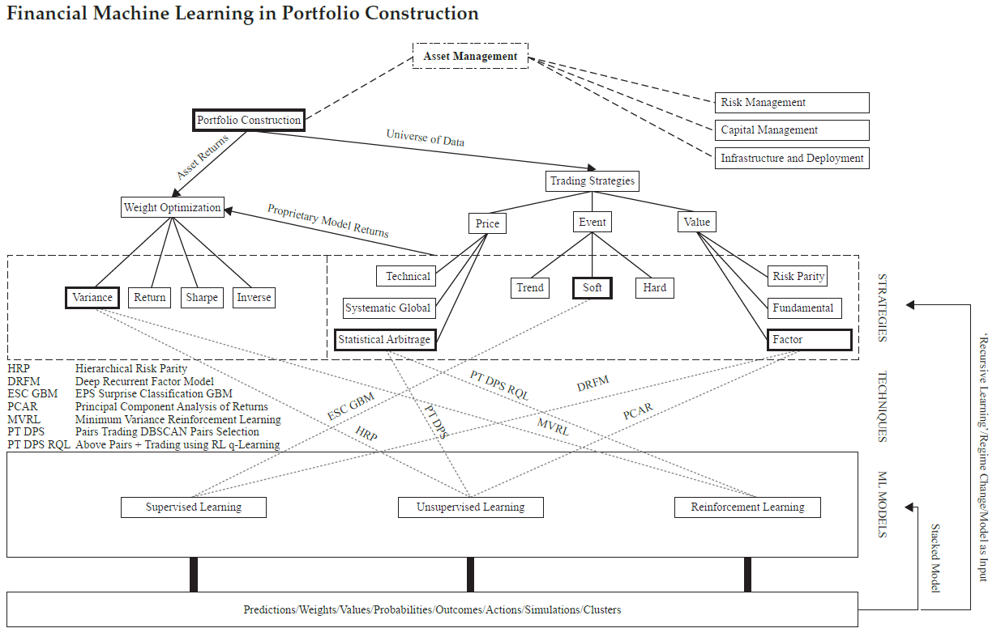

Figure-2.1 Asset Management and Finance Machine learning

1. **Weight optimization** is the process of determining the optimal portfolio from among all portfolios under consideration, based on some objective. When dealing with neural networks, we frequently need to decide which optimization technique will yield faster and better updates to the network's weight and bias parameters. Similarly, current portfolio optimization has shifted away from Markowitz's mean-variance (MV) portfolio based on historical returns and toward dynamic models based on cutting-edge reinforcement learning techniques.

**2.1 Understanding of Portfolio Construction Problem**

The portfolio construction process aims to maximize the return and minimize the investment risk. If there is an N asset involved in the portfolio, the Portfolio management problem can be defined using below mathematical formula:

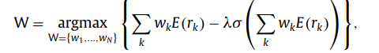 **(1)**



Where,

**Wk:** portfolio weight for the kth asset

**rk:** the return of a kth asset

**k** ∈ {1, …, N}

**σ:** a method to evaluate the risk

**λ:** a weight parameter for the risk value

**E(rk):** the expected return of the kth asset.

Prediction of the expected return of the kth asset plays a crucial role in order to solve the portfolio management problem.

Traditionally, the E(rk) is calculated using a statistical procedure that takes a weighted average of the asset's historical returns over a certain time period from t to T.

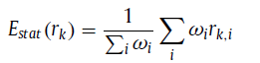  **(2)**

Where,

**ωi:** weight for historical returns

**rk,i:** the historical return of the kth asset at the time i

I ∈ { t, …, T }.

Machine learning techniques provide alternatives for predicting the value of E(rk). ML Models learn from past return data as well as other essential information of assert in this technique. Following that, the Model forecasts future returns based on the sequential data presented.

** (3)**

Where,

**r k,T +ε:** denotes the expected future returns of the asset at time T + ε

**fθ:** the ML model trained with the historical data

**Dk,T:** a set of data given at time T

**2.2 Application of Machine Learning Algorithms in Portfolio Construction**

The phrase "machine learning" refers as an umbrella term to methods and algorithms that enable machines to discover patterns in the absence of explicit programming instructions. ML researchers have done extensive work on portfolio construction using various Supervise, Unsupervised, and Deep learning techniques.

*Tomasz Kaczmarek & Katarzyna Perez (2021)* demonstrated that a **random forest algorithm** can be used to predict the cross-section of expected excess returns. They have built and compared portfolios using three different methods - mean-variance, Hierarchical Risk parity, and 1/N using returns of stocks from the S&P 500 and STOXX600 for robustness. Excess return estimates obtained from machine learning may help to overcome the well-known issues of quadratic mean-variance optimizers associated with sensitivity to changes in inputs. The conclusion of the study shows that both mean-variance and HRP optimizers portfolio optimization methods outperform the 1/N rule.

*Vivek, Zubayr, and Dr. Goswami* worked on portfolio generation using unsupervised Machine learning for the Indian stock market. They have used the **K-mean Clustering algorithm** to ensure Risk Diversification and maintain a healthy rate of return. They choose stocks from these clusters that are closest to the respective centroids and use them to construct an efficient portfolio. The most significant components of this strategy are selecting acceptable investing parameters, determining the optimal value of k, and determining which stocks to select from which clusters. The produced portfolio outperformed the Sensex by 16.21% points and outperformed the BSE100 by 16.89% points. The work's performance clearly demonstrates that machine learning technologies can be utilized to construct varied portfolios that beat market indexes.

There has recently been a lot of interest in stock prediction using deep learning algorithms. Deep learning approaches have recently received a lot of attention, thanks to advances in image processing and natural language processing. *Van-Dai Ta, Chuan-Ming Liu, and Direselign Addis Tadesse (2020)* published a research paper on Portfolio Optimization-Based Stock Prediction using a **Long-Short Memory Network.** Machine learning models such as **Linear Regression** and **Support Vector Regression(SVR)** were also employed to compare the effectiveness of the LSTM prediction model.The portfolio was built by choosing the outperforming stocks from the forecasted results with the highest expected return and the lowest risk. Simulation and optimization models were used to determine the optimal stock allocation for the created portfolio. Equal-weights allocation (EQ), simulation modeling Monte Carlo simulation (MCS), and mean-variance optimization (MVO) were utilized to estimate the best stock allocation weights. When compared to the S&P 500 index, the built portfolios fared well by achieving high returns in both prediction and real trading.

*Ramkumar’s(2021)* works on price prediction of cryptocurrencies compare deep learning neural networks model convolutional neural network (CCN) and Long-Short Memory Network(LTSM) with algorithms traditional prediction model autoregressive integrated moving average (ARIMA). He concluded that the result of the traditional model is low as compared to the neural networks model. Apart from that, he constructed portfolios using tick-by-tick data from the binance using different methods like kelly’s criteria, mean-variance portfolio, and risk parity. Also, Portfolios performance analysis using different parameters like sharp ratio, annualized return, annualized returns, annualized volatility, Sharpe ratio, Sortino ratio, beta, Treynor ratio, information ratio, and maximum drawdown are calculated for each portfolio, and the best portfolio is chosen.

**2.3 Portfolio Construction Method**

There are numerous portfolio construction methods that can help to reduce investment risk while optimizing asset returns. DeMiguel, Garlappi, and Uppal (2007) compared the performance of the mean-variance model and its expansions to that of the naïve 1/N portfolio. The 1/N portfolio strategy is also referred to as an equal-weighted portfolio. In terms of Sharpe ratio and turnovers, the equal weight portfolio technique beats 14 models assessed across seven sample datasets and suggests optimal diversification, This implies that there are many "miles to go" before the profits promised by optimum portfolio selection can be realized outside of the sample.

Markowitz [1952] represents the beginning of contemporary portfolio theory, in which the issue of portfolio selection is properly articulated and solved for the first time. Before he could establish the "expected returns-variance of returns" rule, Markowitz had to debunk the commonly held belief at the time that an investor picks a portfolio by picking stocks that maximize returns. He believes that the Mean-Variance rule involves not just diversity, but also the correct sort of diversification for the right reasons.

The Kelly criteria are used by gamblers and investors to maximize profits over long periods of investment or betting. The paper by Peterson (2018) explains how the Kelly criterion may be used in the typical portfolio creation procedure, which includes the risk function. The experiment was carried out utilizing ten equities from major stock exchanges and several evolutionary algorithms. He compared the average return of Kelly's criterion portfolio with the mean-variance portfolio using the Monte Carlo simulation. His research indicated that Kelly's technique may be utilized to design a portfolio that achieves the same optimal returns as a mean-variance portfolio.

Risk-based investing methods are also appealing to investors and have grown in popularity in academia and practice. Burggraf (2019) assessed seven cutting-edge portfolio creation approaches for cryptocurrency investors (e inverse volatility, minimal variance, l2-norm restricted minimum variance, l2-norm constrained maximum decorrelation, maximum diversification, and risk parity portfolio). The variance-covariance matrix, which is used to find the best portfolio allocation, is a feature shared by all portfolio approaches. As a result, portfolio weights are less sensitive to estimating the mistake in expected input. According to the analysis, risk-based strategies beat 13 cryptocurrencies and equal-weight portfolios in terms of return and volatility. Risk-based techniques aid in the protection of investors during difficult times.

**References**

Snow, D., 2020. Machine learning in asset management—Part 1: Portfolio construction—Trading strategies. *The Journal of Financial Data Science*, *2*(1), pp.10-23.

Yun, H., Lee, M., Kang, Y.S. and Seok, J. (2020). Portfolio management via two-stage deep learning with a joint cost. Expert Systems with Applications, 143, p.113041. doi:10.1016/j.eswa.2019.113041.

‌

Peterson, Z. (2018). The Kelly criterion in portfolio optimization: a decoupled problem. *Journal of Investment Strategies*, 7(2), pp.53–76. doi:10.21314/jois.2017.097.

‌DeMiguel, V., Garlappi, L. and Uppal, R. (2007). Optimal Versus Naive Diversification: How Inefficient is the 1/NPortfolio Strategy? Review of Financial Studies, [online] 22(5), pp.1915–1953. doi:10.1093/rfs/hhm075.

Burggraf, T. (2019). *Risk-Based Portfolio Optimization in the Cryptocurrency World*. [online] papers.ssrn.com. Available at: https://papers.ssrn.com/sol3/papers.cfm?abstract_id=3454764 [Accessed 21 Dec. 2022].

Ramkumar, G., 2021. Cryptocurrency Portfolio Construction Using Machine Learning Models. In *Contemporary Trends and Challenges in Finance* (pp. 103-122). Springer, Cham.